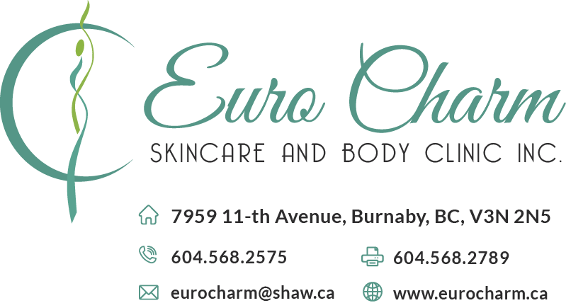

For Vascular Laser Clients:

With Vascular treatments the laser targets is hemoglobin which is color of the blood; Laser beam catches this color and dissolves the veins or vessel. We are able to treat Leg Spider Veins, facial veins/capillaries, Cherry Anginomas, Port Wine Stains.

Each time a client has approximately 30% of reduction of the condition they came with. It is multiple times treatment. This condition is genetic, so people may develop new veins with a time.

Prior to Laser Vascular Treatment

- No sun exposure at least 2 weeks before treatment.

- No self tanner creams or sprays on the area being treated.

Pain Prevention

- Take 2 Tylenols 30 min before treatment, NOT Advil, Aspirin or Ibuprofen (blood thinners, increase the chance of bruising).

- Emla Cream ($95 in Pharmacy) or Zensa Cream ($35 in our premices) (topical anesthetic) should be applied on the target area 1 hour before the treatment (thing layer) and covered with Saran Wrap.

- Treatment can be more painful a week prior to your period and first four days (due to hormonal misbalance).

Bruising Prevention

- Orally Arnica Homeopathic pills or Bromenlane (pineapple enzyme) 3-4 days prior to treatment.

- Topically apply Arnica cream to target area 2 times/day to aid in healing after treatment.

Post Laser Vascular Treatment

- Local swelling, bruising, blistering, redness and heat in the area treated are common.

- Ice Packs or wet cold towels on treated area may be applied.

- No sun exposure 2 weeks after treatment. It may lead to pigmentation where the vein was treated.

- Do not heat up your body with hot baths, sauna for 2 weeks after tx. Avoid vigorous exercises (at least for 4 days). Fast walking is OK.

- Blisters are a possibility, treat by applying Polysporin and don’t pick the scabs up.

Post care for facial Treatment

- Swelling can last up to 2 weeks after treatment.

- May take an Antihistamine (Benadryl) to help with swelling.

- Blisters are also possible on the face treat with Polysporin.

- Do not apply Arnica cream to the face it can be drying to the skin.

- To prevent the swelling: sleep with an elevated head and reduce water consumption after 6:00pm prior to sleep.

- Bruising may last from 1 to 6 months depending on the veins diameter. Arnica oral peels and cream may speed up the healing process.